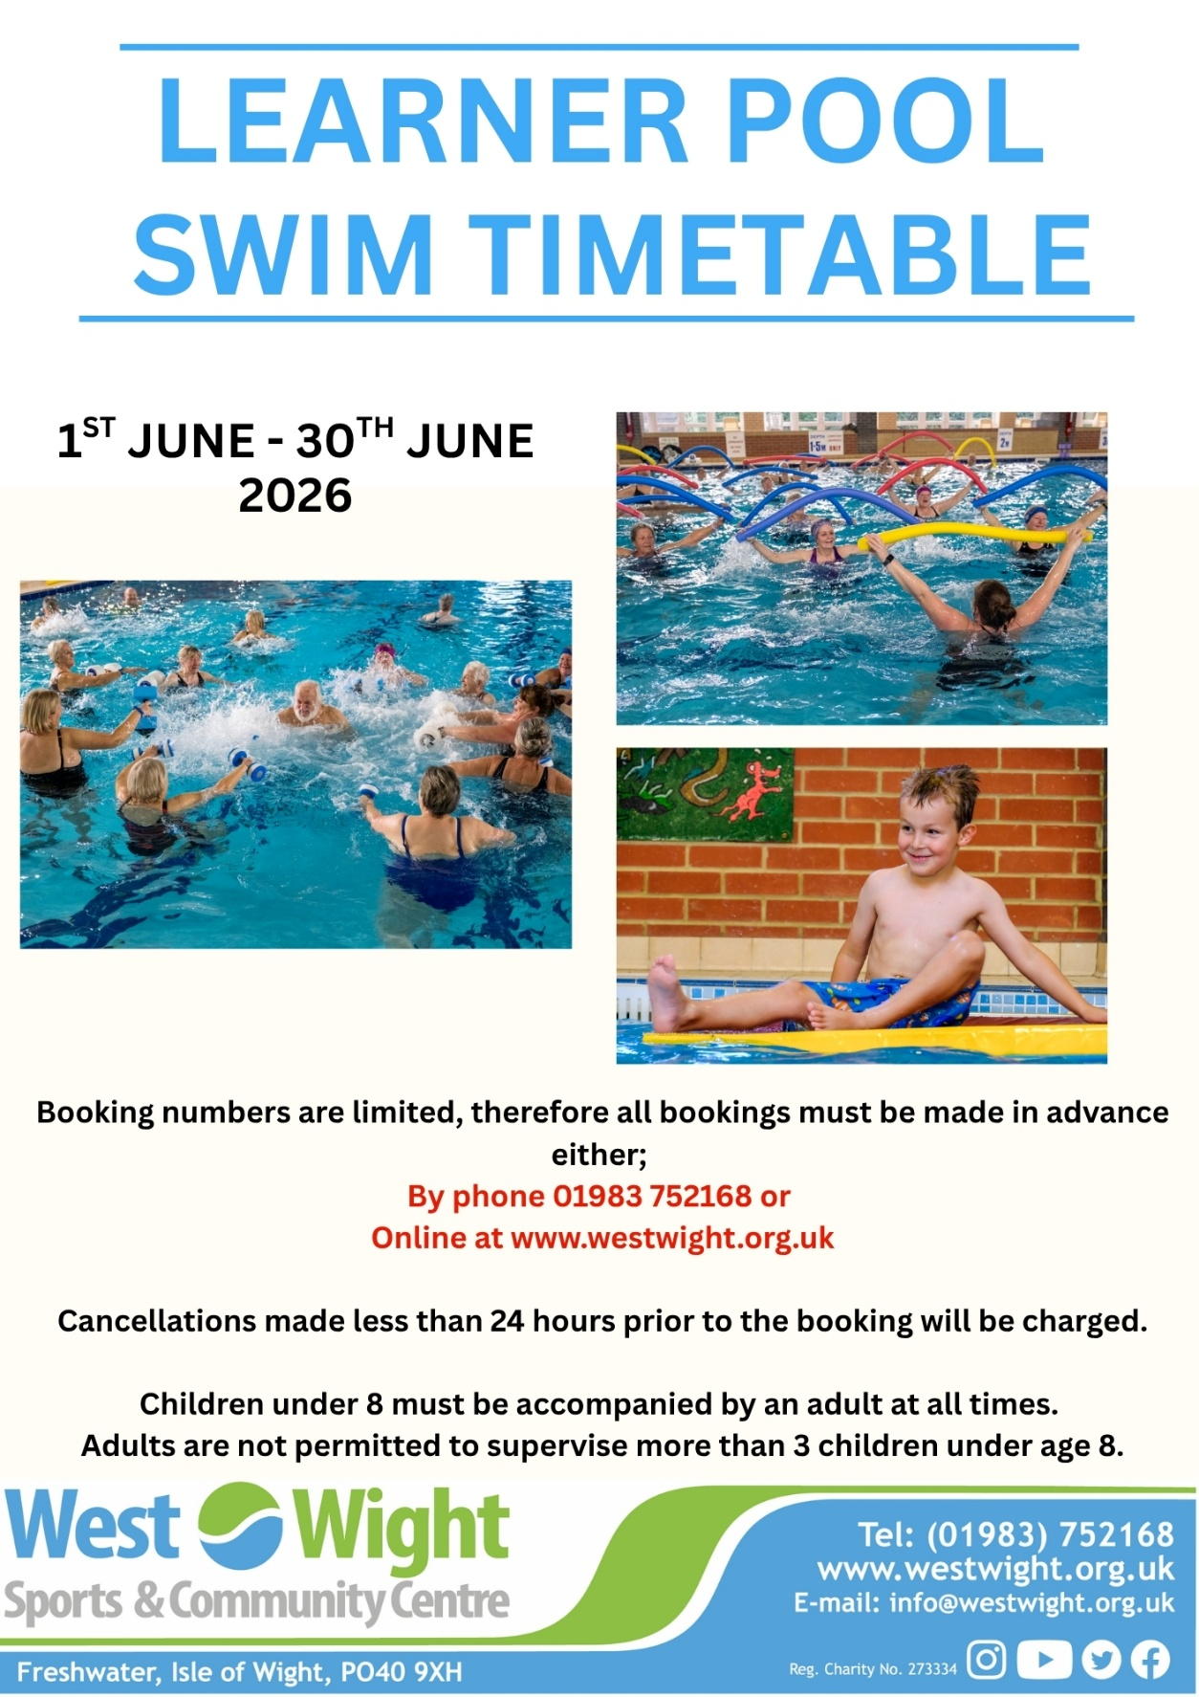
Please note you must be registered before booking online – this can be done with our reception team.
Pay-as-you-go Charges Fun Hour
Adult Swim £6.90 Adults/Under 20’s £4.80
Under 20’s £3.20 Under 4’s FREE
Under 4’s FREE

Baby and Toddler Classes
Parent and baby – This session is suitable for children up to the age of 2, accompanied by an adult, the session includes games, songs and lots of fun.
Tweenie Swim – For children aged 2-3 years, a fun introduction to swimming, accompanied by an adult, involving structured games and activities.
Swimming tots – For children aged 3-4 years, preparation for swimming lessons, accompanied by an adult, children will learn with singing, games and structured play.

Public Swimming
Suitable for all ages
Open Swim Fun hour
A session with diving boards and no A session with mats across both
lane ropes, across both pools pools

Available for hire
Please enquire at reception to learn more
Memberships
Swimming is included in Swim single/Couple and Diamond Plus memberships, please enquire at reception for more details.
Aqua Mobility
10.00 – 11.00
Public Swimming
6.00 – 10.00
Public Swimming
11.00 – 13.00
Public Swimming
15.00 – 20.00
Public Swimming
9.00 – 11.00
Public Swimming
18.00 – 20.00
Public Swimming
12.00 – 13.00
Public Swimming
15.00 – 16.00
Reserved for School Swimming Lessons
13.00 – 15.00
Swimming
Lessons
16.00 – 18.00
Pheonix Project
11.00 – 12.00
Public Swimming
7.00 – 9.00
Public Swimming
15.00 – 20.00
Swimming
Lessons
16.00-17.00
Hydrotherapy
9.00 – 13.00
Public Swimming
18.00 – 20.00
Public Swimming
15.00 – 16.00
Swimming
Lessons
16.00 – 18.00
Hydrotherapy
11.30 – 13.00
Parent and Baby
9.00 – 9.45
9:45-10:30
Public Swimming
7.00 – 10.00
Public Swimming
15.00 – 20.00
Public Swimming
12.00 – 13.00
Pheonix Project
11.00 – 12.00
School Swimming Lesson

Public Swimming
7.00 – 9.00
Public Swimming
8.00 – 10.00

Public Swimming
11.00 –14.00

Public Swimming
11.00 –14.00
Fun Hour
10.00 – 11.00
Open Swim
14.00 – 15.00
Open Swim
14.00 – 15.00
Swimming Lessons
9.00 – 11.00
C L O S E D
C L O S E D

Tweenies
10:30 – 11:00

Swim Tots
11:00 – 11:30

Reserved for School Swimming Lessons
13.00 – 15.00
Reserved for School Swimming Lessons
13.00 – 15.00
Reserved for School Swimming Lessons
13.00 – 15.00
Available for hire
15.00 – 17.00
Available for hire
15.00 – 17.00

Public Swimming
13.00-15.00

